Spicy Tofu Rice Bowl
Inspired by


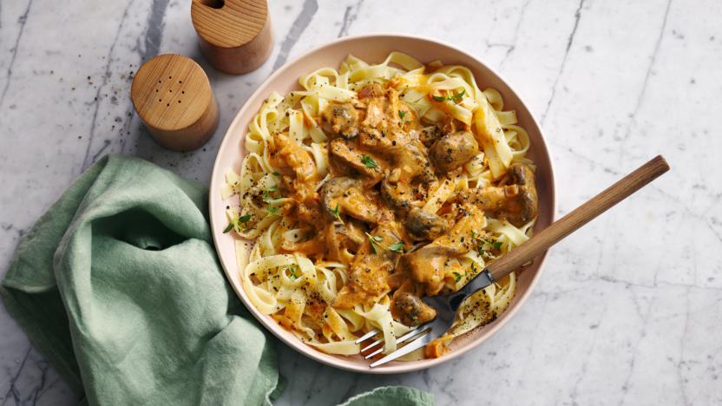
DID YOU KNOW?
“FACT ABOUT TENDERSTEM BROCOLLI!”

Nutrition – Total / Per Serving
Calories: ?kcal / ?kcal
Carbohydrates: ?g / ?g
Protein: ?g / ?g
Fat: ?g / ?g
Fibre: ?g / ?g
Sugar: ?g / ?g
Ingredients
280g firm tofu
1 carrot
150g jasmine rice
80g tenderstem broccoli
15ml rice vinegar
½ tbsp chilli
½ tsp sugar
15ml soy sauce
2 tsp sesame seeds
? SPICES
?BULGOGI SAUCE


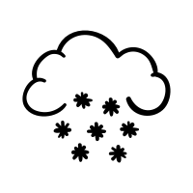



Good for:

Star Rating:

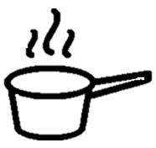

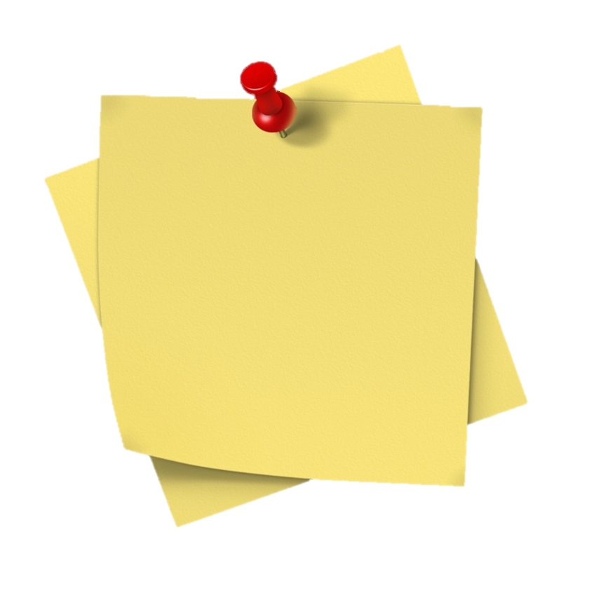
Method

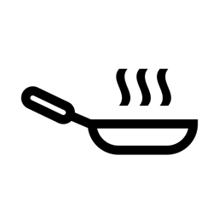

Step 1 - Preparation
Boil the kettle with the required water for the rice.
Slice the garlic.
Halve any thick stems of the tenderstem broccoli.
Slice the carrots into ribbons (either using a mandolin or a potato peeler).
Cut the tofu into 2cm chunks, pat them dry and place into a bowl and set aside.

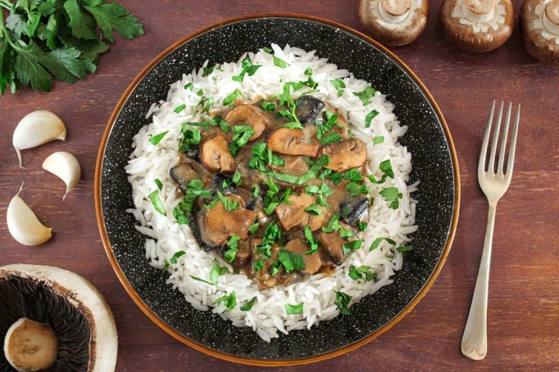
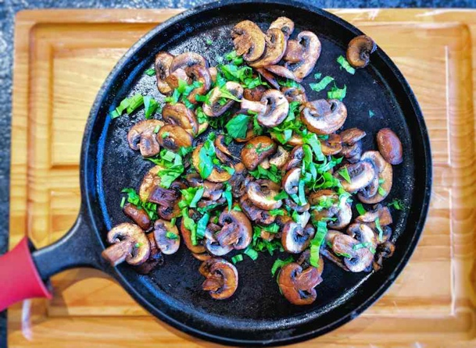
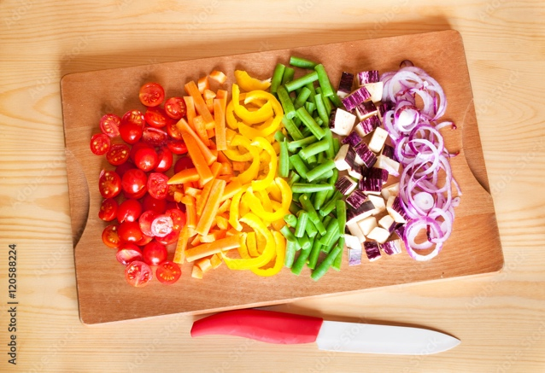
Step 3 – Fry the Greens
Heat the frying pan with some oil, once hot, add the tenderstem broccoli and fry for ~2 minutes, add the garlic and then add a splash of water.
Cover the pan (foil or lid) and let it cook for another ~2 minutes or until tender.
Season with salt and pepper to taste before removing from the pan and setting aside.

Step 4 – Fry the Tofu & Bring it Together
Place the frying pan back on heat and drizzle with oil before adding the tofu. Fry until crispy (~9 minutes).
Once golden add the ?, ?,?. Mix well before adding the ? sauce???, chilli and 7ml of soy sauce. Mix to combine.
Bring the frying pan to a boil, then reduce to a simmer and allow the sauce to thicken (~1 min.).

Add 7ml soy sauce to the rice, and dish up. Garnish with the broccoli, tofu, and carrots.

Enjoy!

Enjoy!
Step 2 – Rice Rice Baby & Pickle Your Carrots
Cook the rice according to the package instructions.

Place the carrot ribbons into a small bowl together with the rice vinegar, sugar and a pinch of salt.
Mix together and set aside.

